**Project Conclusion**

**Landscape classification**

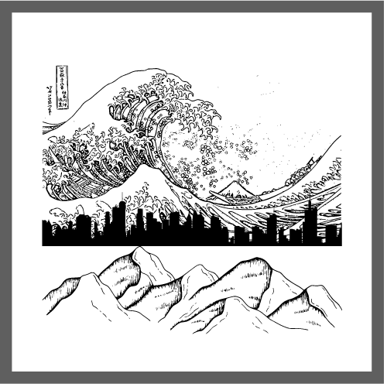

**Name:** Hristo Hristov

**Email:** [h.hristov-ab@student.fontys.nl](mailto:h.hristov-ab@student.fontys.nl)

**Student Number:** 4170431

**Teachers:**

Zhao Qin – [q.zhao@fontys.nl](mailto:q.zhao@fontys.nl)

Hans Konings – [h.konings@fontys.nl](mailto:h.konings@fontys.nl)

John Litsenburg – [j.litsenburg@fontys.nl](mailto:j.litsenburg@fontys.nl)

**Fontys University of Applied Sciences**

**Eindhoven – Netherlands**

**2022**

Contents

OVERALL UNDERSTANDING 3

THE PROS AND THE CONS 3

PROS 3

CONS 3

OVERALL NOTEBOOK 4

DAIA (DATA CLEANING AND VISUALIZATION) 4

ML (PREDICTION) 6

CNN 6

SVM 7

FUTURE IMPACT ON SOCIETY 7

REFRENCES 10

# OVERALL UNDERSTANDING

With the advancement of technology more and more everyday tasks are becoming automated. Nature photography is now easier than it’s ever been in the past. Traveling is more streamlined and simpler. Natural areas are often more accessible. Not to mention the fact that digital cameras are everywhere. A typical nature photographer can take up to 100-300 photos in one day because from each location they can pressed the shutter around 30-40 times to get a result that they want. Also, most of the people who’s going on vacation they can took more than 1000 picture during the vacation. Having to manually go through each picture and manually put it a correct folder corresponding to the type of photo is not something that is practical thus no many (if any) people do it because it took a lot of time.

Because of this problem I have decided to do Image classification for my project and it can be used by most people especially the photography enthusiast.

# THE PROS AND THE CONS

## PROS

**No manual sorting –** By using my A.I. people will not have to sort each image individually into folders. The machine will do it for them.

**More free time** – The time people would have spent on organizing their photos, they can spend on something they enjoy doing.

## CONS

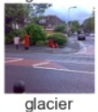**Miss predicted images** - No A.I. can perfectly predict, and thus sometimes the machine will miss predict the picture and give us a wrong category for the picture, for an example on my project there’s some miss predicted pictures like this one, where the machine that a street is actually a glacier.

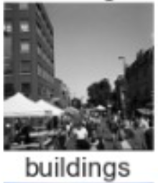Another example is the algorithm got confused by the images because it can be both like this example, in the image it shows that there’s a building, but we want the algorithm to classify this image as a street. The solution to this is of course having to manully sort the pictures correctly. Although the time that fixing the miss predicted images is much less than the time to manullay sort all of the images. So in the end, I belive for most people the positives will outweght the negatives.

# OVERALL NOTEBOOK

## DAIA (DATA CLEANING AND VISUALIZATION)

After I collect and prepare the data I want to check if all the images are having the same width and height. Here we can see that all the width and height is the same.

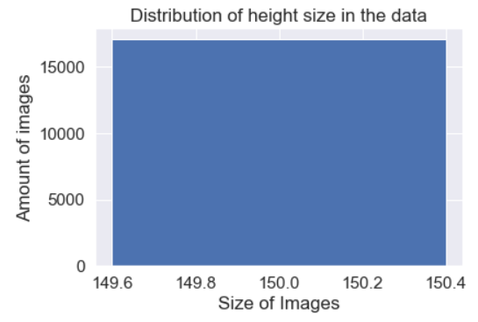 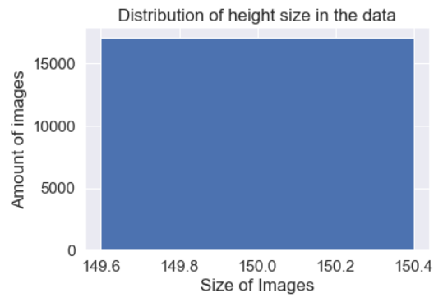

I want to check if the data is evenly distributed because the data distribution is really important for the result of the prediction. Here we can see that the image was distributed equaly so we do not have to manually shuffle it.

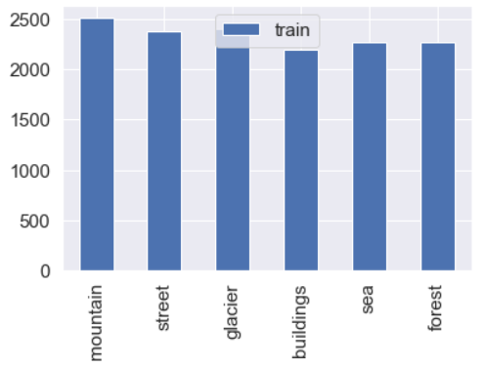 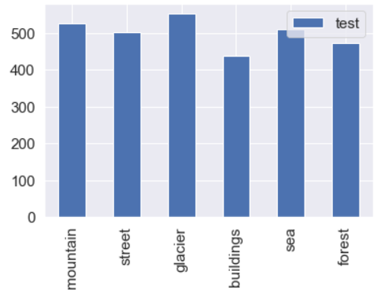

## ML (PREDICTION)

There are 2 algorithms that I will compare the first one is CNN and the second one is SVM. Let’s start with CNN first and see the result.

### CNN

From this diagram we can see that each epochs took 150s so by the time it’s finished in the 4th epochs the total durations is 700s.

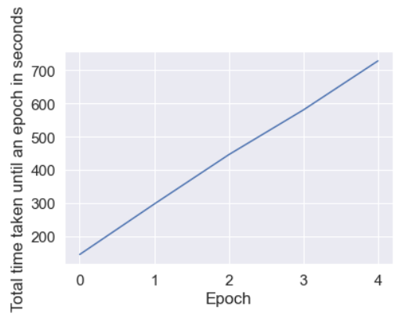

Here it shows that the more we train the data the higher accuracy that we will get. But we have to keep in mind that we can’t over fit the model.

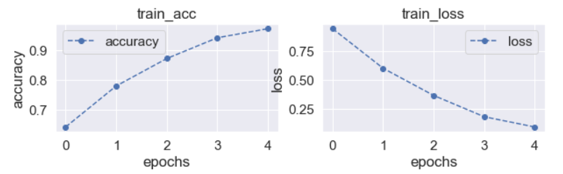

At the end we got the final accuracy, and the accuracy is not bad

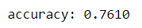

### SVM

For this model I got a lower accuracy than the previous one, but It is understandable, because the SVM model is older than CNN. CNN is more cutting-edge technology wise, compared to SVM.



From this image we can see that our SVM model is struggling with correctly making a distinction between sea and buildings, mountain and forest, glacier and sea. We can use this information to further improve the algorithm in the future

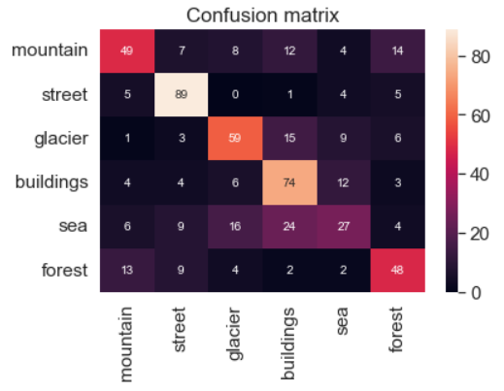

# FUTURE IMPACT ON SOCIETY

I will approach this topic in 2 ways: the future impact on society that my project will have and the impact that image recognition in general will have.

**Personal Project –** As my project is centered around photographers and my target users. They are the ones who will be impacted the most. By using this technology photographers will have an automatically sorted collection of photos, which they can use to find the picture they are looking for more easily. Another group of people who will be impacted by this technology is people who sort photos for a living. Should this technology gain traction and become widely used, most people who are in the profession of sorting images might suddenly have a lot less work and might force people to give up their profession in search of another one.

**Image recognition in general** - Right from the safety features in cars that detect large objects to programs that assist the visually impaired, the benefits of image recognition are making waves. Evan Nisselson of the LDV Capital even stated that, "Currently, the advances in computer vision are providing tremendous, new opportunities to analyze images that exponentially impact various business verticals, from advertising to automotive". With the application of Artificial Intelligence across numerous industry sectors, such as gaming, natural language procession, or bioinformatics, image recognition is providing help to these field to make huge advancements in their spheres.



On the other side of the debate of whether image recognition is good or bad are many examples of the technology being misused or used on purpose for nefarious purposes. Threat to privacy, imposes on personal freedom and violation of personal rights are just some of the concerns that critics bring forward. To give a real-life example, countries like China have been using facial recognition for years to track people and make sure they do not oppose the communist regime and communist party. Any opposition being swiftly eliminated. Another concern is that as mentioned before, A.I. technology is not immune to mistakes. At some point in some part of it’s prediction it will make a mistake and it can lead to many incidents/catastrophes. Ranging from a person being misidentified for a crime he did not commit, to a car’s self-driving function malfunctioning and running a family crossing the street.



Regardless of pros and cons of image recognition, science is not stopping with its advancements in the field, making A.I. even more “intelligent”.

# REFRENCES

Patel, V. (2022, January 5). *How many photos do you take at a Nature Photography Location?* Visual Wilderness. Retrieved May 18, 2022, from <https://visualwilderness.com/fieldwork/how-many-photos-do-i-take-at-a-nature-photography-location>

Singh, A. (n.d.). *26 Best Photo Organizer Software and Apps of 2022*. Pixpa. Retrieved May 18, 2022, from <https://www.pixpa.com/blog/photo-organiser>

Kurniawardhani, A., & Marfu’ah, N. J. L. (2018). *Comparison of CNN and SVM for Ship Detection in Satellite Imagery*. <https://dspace.uii.ac.id/bitstream/handle/123456789/20216/08%20naskah%20publikasi.pdf?sequence=11&isAllowed=y#:~:text=Detection%20of%20ships%20in%20satellite%20imagery%20successfully%20uses%20machine%20learning,is%20longer%20than%20SVM%20does>.